Peer-reviewed journal articles:

Buntting, C. (2023). Building a positive future for science education through teacher-researcher partnerships. International Journal of Science Education and Teaching, 2(3), 127-134.

Buntting, C., Doyle, C., Anderson, D., & Luczak-Roesch, M. (2021). Weaving a web of connections through online citizen science. New Zealand Annual Review of Education, 26, 69–75. doi: 10.26686/nzaroe.v26.
Buntting, C., Moeed, A., Anderson, D., & Miller, R. (2022). An evidence-based approach to secondary school science: Online citizen science and the science capabilities. Curriculum Matters, 18, 46-65.
Doyle, C., Pierson, C. M., Buntting, C., & Li, Y. (2021). Learning to teach from home. SET: Research Information for Teachers, (1), 60–66. doi:10.18296/set.0196
Doyle, C., Ross, S., Buntting, C., Boucher, M., & Kotze, T. (2023). Training an AI rover for Mars. Why and how? SET: Research Information for Teachers, 2, 41-48.

Egerton, B., Moeed, A., Bunting, C., & Ross, S. (submitted). Using online citizen science as context and driver for integrating DT and science curriculum learning. Journal of Science Education and Technology.

Other articles:

Christenson, D., Roberts, J., & Hipkins, R. (2021). Place-based learning: Reflections on the value of repeated field trips. Set: Research Information for Teachers, 3, 2–5. doi:10.18296/set.0205
Education Gazette Editors. (2020). Mouldy bread and microscopic beasts. Education Gazette, 99(12). Retrieved from https://gazette.education.govt.nz/articles/mouldy-bread-and-microscopic-beasts/?fbclid=IwAR2Oy_s7oyGNfdLi3HXxqh6l7abAPGMZgUpVxhbpiTz0BRuiMWxc3ShmvyU

Teacher-facing presentations:

Miller, R., & Buntting, C., & (2020, October). Travelling to Mars? Oral presentation at ULearn online education conference. Available at https://www.youtube.com/watch?v=BpI_Axag59k
Brieseman, C., & Buntting, C. (2021, October). Being citizen scientists online. Oral presentation at ULearn online education conference.
Boucher, M. (2021, October). Online citizen science in the classroom. Oral presentation at ULearn online education conference.
Buntting, C. (2022, July). Using online citizen science to contribute to international climate change research. Teaching science: Making learning relevant inside and outside the classroom. A workshop hosted by NZ Association of Primary Science Educators and Teacher Development Aotearoa. Auckland, NZ.
Buntting, C. (2022, November). Using online citizen science projects to support primary school students to think scientifically. Oral presentation at the Singapore International Science Teachers Conference (online).
Christenson, D., & Buntting, C. (2023, April). Teacher-researcher partnerships: Collaborating for good. Oral presentation at SCICON23. Hamilton.
Egerton, B., & Ross, S. (2023, April). Developing students’ digital skills through online citizen science. Oral presentation at SCICON23. Hamilton.

Researcher-facing presentations:

Doyle, C., & Buntting, C., (2020, July). Weaving a web of connections through online citizen science. Cancelled Conference Conversations. A virtual symposium series.
Buntting, C., & Doyle, C. (2020, November). Online citizen science as a cross-disciplinary research connector. Oral presentation at Contemporary Approaches to Research in Mathematics, Science, Health, and Environmental Education Symposium. Melbourne, Australia [Virtual Conference]. Available at https://youtu.be/VzZCtAO
Buntting, C., & Coton, M. (2021, July). Online citizen science: Multiple opportunities for learning. Invited webinar for the STEM Special Interest Group, Australian Association for Research in Education.
Buntting, C., Anderson, D., & Christenson, D. (2021, July). Investigating students’ views of their science capability development. Online presentation at the annual conference of the Australasian Science Education Research Association.
Egerton, B., & Glasson, B. (2022, July). ‘Researcher’, ‘teacher’, ‘other’? Considering a non-scientist’s role in a science-focused research project. Oral presentation at the annual ASERA (Australasian Science Education Research Association) conference. Online and in Perth.
Glasson, B., & Egerton, B. (2022, July). Science and digital technology - An evidence-based integration. Oral presentation at the annual ASERA (Australasian Science Education Research Association) conference. Online and in Perth.
Buntting, C. (2023, May). Building a positive future for science / STEM education through teacher-researcher collaborations. Keynote address at The 10th International Conference for Science Educators and Teachers (ISET) 2023. Phuket, Thailand.
Buntting, C., & Soanes, A. (2023, October). Empowering education: Using citizen science to enhance science education in New Zealand. Invited presentation. International Symposium on Citizen Science 2023. Online, hosted by Universiti Teknologi Malaysia.

Other:

The image On2Science: Weaving a web of connections through online citizen science celebrated the collaboration underpinning this project as part of an ‘Images of Research’ exhibition hosted by Te Whare Wānanga University of Waikato,
see https://www.waikato.ac.nz/wmier/images-of-research

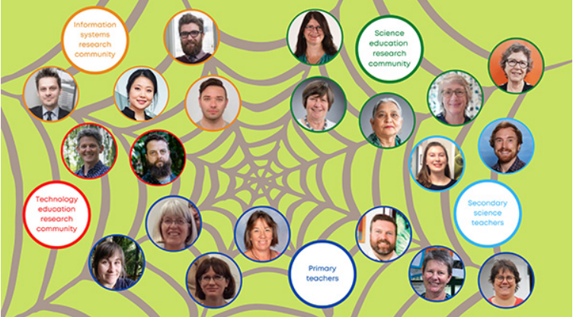

Online citizen science project pages on the Science Learning Hub:

- Wild Sourdough
- AI4Mars
- The Great Kiwi Earthworm Survey
- Skink Spotter NZ
- The Pieris Project
- Penguin Watch
- Fossil atmospheres

