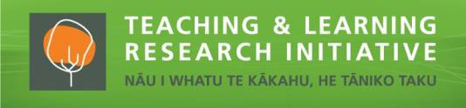
Maaku anoo e hanga i tooku nei whare
I will build my own house
Ngārewa Hāwera & Leeana Herewini Project dates: 1 January 2018 to 30 March 2020

Intro / Project description

This project positions kaiako and community as key to advancing aspirations for their tamariki. It involves collaborating with six kaiako and their aakonga in a Modern Learning Environment (MLE) to explore and enhance paangarau teaching and learning experiences

Aims

The goal of this project is to explore ways that aakonga (student) engagement and achievement in paangarau (mathematics) in a Maaori Medium (MM) MLE setting can be enhanced. This project aimed to explore the challenges and advantages of teaching and learning paangarau in one Year 4-6 MLE in a wharekura. In the first year, we explored current paangarau teaching and learning experiences, understandings, attitudes and beliefs. In the second year, we worked together to trial and refine innovative paangarau teaching approaches that take advantage of the affordances of the MLE to strengthen learning experiences for kaiako (teachers) and aakonga. Findings contribute insights into MLE paangarau pedagogies generally in Aotearoa and more specifically, those in a MM MLE setting. Project findings aim to be of interest as well to other international indigenous contexts seeking to enhance mathematics learning for their aakonga.

The overarching questions guiding this work:

What are kaiako views of the challenges and advantages of teaching and learning paangarau for Years 4–6 in this MLE?

What are aakonga views about the challenges and advantages of learning of paangarau in this MLE?

How can kaiako leverage the affordances of this MLE to strengthen the engagement, and achievement by ākonga in paangarau?

Why is this research important?
Early research suggests that MLEs are settings requiring different thinking regarding the use of space and physical elements (buildings, furniture) and non-physical elements (pedagogy). There is little research about how to teach paangarau effectively in MLEs in Aotearoa, especially in MM settings. The timing and focus of this research is also significant given government policies emphasising the importance of enhancing student engagement and achievement in paangarau while promoting MLEs as sites for developing students as 21st-century learners.
This research will provide opportunities for kaiako to reflect on and develop their own pedagogical knowledge for this relatively new teaching context. The effect of evolving practices in an MLE and their impact on engagement and achievement of aakonga warrants exploration if only to adapt and ensure the worthiness of such initiatives for the aspirations and goals of MLE.

Key findings

One finding from the research project is the naming of a MLE as a Puna Maatauranga Kiritoa (PMK). The name PMK locates and conceptualises a MLE in one MM setting as a place or Puna (source of learning) where Maatauranga (education) is important, and the notion of Kiritoa, requiring participants to be strong and resilient is promoted.

Our findings identify three key areas for careful consideration when designing, establishing, and developing a PMK. Collaboration, fostering productive learning pathways and the use of technology are significant components that warrant attention when strengthening the teaching of paangarau in a PMK. Mahi ngaatahi or collaboration is a critical element that highlights the way in which aakonga and kaiako can work effectively in a PMK. Teacher pedagogy is reaffirmed as an important factor affecting children’s engagement and learning in paangarau while Hangarau Matihiko, which is promoted as a key feature of a MLE/PMK, is an area for further development in a MM context.

Implications for practice

Work together with colleagues while promoting collaboration amongst aakonga

Explore the use of investigative tasks to enhance student engagement and self-management skills while strengthening learning in paangarau

Promote student choice and hangarau matihiko as key factors for encouraging student engagement, self-management and learning

Review and incorporate strategies for teaching mixed ability groups

Consider and manage noise levels for positive student interactions that are essential for learning paangarau

Our partners:
Kaiako, aakonga and senior leadership team from Te Wharekura o Raakaumanga in Huntly are our partners.

Contact details:
Leeana Herewini
Wilf Malcolm Institute of Educational Research, The University of Waikato, Private Bag 3105, Hamilton 3240
leeana.herewini@waikato.ac.nz
027 240 8942
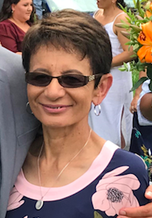
Ngārewa Hāwera
Wilf Malcolm Institute of Educational Research, The University of Waikato, Private Bag 3105, Hamilton 3240
ngarewa.hawera@waikato.ac.nz
027 471 7676

