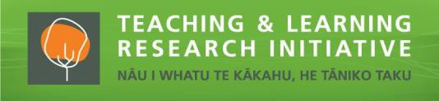
Understand Me: Crafting Selves and Worlds in Collective Storied-Conversations with
Tamariki/Children, Whānau/Families and Kaiako/Teachers

Marieta Morgan, Jacoba Matapo, Janet S. Gaffney, Meg Jacobs, & Alison M-C Li Project dates: 10 December 2020 – 31 March 2023

Mā ngā korero tuku iho tātou me ō tātou ao e kitea ai, e rongongia ai, e whaiora ai.
E tatou te fauina i tatou ma a tatou si’osi’omaga, e ala iā tatou tala.

We craft ourselves and our worlds in stories.

Project description
Understand Me was an aspirational exploration for deepening teachers’ relationships with children and their families through storied-conversations. The project partners explored how storied-conversations carved pathways of understanding between home and school in a community representative of the superdiversity of Tāmaki Makaurau. Understand Me offered a
reflective space to imagine how storied-conversations could inform curriculum and pedagogies. Children and adults storied their worlds multimodally across generations, inclusive of family languages and cultures. Storied-conversations occurred in and out of classrooms. The recorded conversations included families who identified as Māori, Samoan, Tongan, Tongan-European-Māori, Fijian, Bangladeshi, and Pakistani. Teachers unearthed everyday storied-conversations and incorporated their learnings to enhance the school-sanctioned curriculum. By enriching the local curriculum with new understandings contributed by children and families, the school embraced their place as the centre of the community.

Research questions
- How might a child, parent, and teacher better see and understand each other’s worlds through storied-conversations?
- How might knowings, already existing in the everyday lives of children and families, forge a pathway from home to shape curriculum and pedagogies?

How might educators embrace the tensions between the relational and the quantifiable to reimagine curriculum through storying with children and families?

Evolutions of the methodology
- Storied-conversations evolved from being formally scheduled and deliberately spaced, to pop-up stories that became more visible in the everyday.
- Co-design talanoa was an organic shift from the planned approach of Critical Participatory Action Research, which better reflected the way project partners desired to engage.
- Whānau-supported transitions to school for young children was a natural evolution of the project, with younger siblings, not yet school-aged, engaging in storied-conversations alongside parents and siblings.

Key findings
- Storied-conversations with people, places, and things were hidden in plain sight.
- Through co-design talanoa, teachers co-created a nurturing space to slow down, reflect, share new understandings and interrogate tensions in their work.
- Storied-conversations invited potentialities in which children, whānau, and teachers saw each other and themselves in new ways.
- Home and intergenerational family pedagogies were unearthed in storied-conversations, shifting the directional flow of knowledges and challenging social hierarchies.
- The school embraced its family-gifted place.

Implications

Collectively engage in professional learning-research: Blur the lines between research and pedagogy by creating space to co-compose professional learning conversations for deliberate curriculum innovation.

Collectively embrace the tensions: Move towards understanding the unknown by presencing children and whānau. Genuinely engage with taken-for-granted curriculum to surface culturally located assumptions and beliefs that misrecognise differences as deficits.

Collectively sustain the everyday work of understanding: Value the stories of the people and the place to continuously shape the school’s official curriculum to reflect the community.

Project partners
Marieta Morgan is Samoan-born, Jacoba Matapo is Samoan-Dutch, Janet Gaffney and Meg Jacobs are American of European descent, and Alison Li was born in Hong Kong. In addition to Principal Stan Tiatia (Samoan) and Deputy Principal/co-author Marieta Morgan, 16 teachers from Papatoetoe North School contributed, representing the following self-identified ethnicities: Māori-Pākehā, Māori-Cook Islands Māori-Aboriginal-Irish, Samoan, Tongan, Samoan-Tongan, Tahitian-Cook Islands Māori, Indian, Cambodian and New Zealand European/Pākehā.
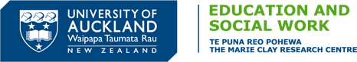
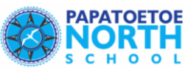
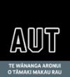

Contact details: janet.gaffney@auckland.ac.nz

